Using the CD, DIR, and MKDIR Commands

Lane Dorscher
CS 200 Systems Fundamentals
Bellevue University Computer Science
09/12/2025
Dr. Robert Flowers

Introduction
The command line interface (CLI) can seem intimidating at first, but understanding its basic commands is essential for navigating and managing files efficiently. Learning to navigate the file system through the CLI provides a strong foundation for more advanced computing tasks. Three fundamental commands are critical for this: changing directories using CD, viewing directory contents using DIR, and creating new directories using MKDIR. Mastering these commands allows users to move through the file system, inspect its structure, and organize files effectively.

Command Basics
Change Directory (CD) Command
When working in the Windows operating system’s CLI, the CD command is essential for moving between directories. This command changes the current working directory to a specified target directory (Microsoft, 2024). For example, opening Command Prompt typically starts in the user’s home directory (e.g., C:\Users\[user]). Typing cd Documents will navigate to C:\Users\[user]\Documents. If the requested directory does not exist, the command will display an error stating, “The system cannot find the path specified”. Folders with spaces in their names require quotation marks for accurate navigation, such as cd "My Documents". Additionally, navigating back to a parent directory is simple using cd ... Overall, the CD command is straightforward yet powerful, forming the backbone of CLI navigation.

Directory (DIR) Command
After navigating directories, it is important to know what files and folders exist in the current location. The DIR command lists all available contents of the active directory (Microsoft, 2023b). The output is organized into columns showing the last modified date, last modified time, an indicator for folders (<DIR>) or the size of files in bytes, and the names of files or folders. At the bottom, DIR provides a summary that counts the total number of files, the number of directories, and the remaining free space on the drive. Special entries like . and .. represent the current working directory and the parent directory, respectively. By using DIR, users can quickly identify files, folders, and available space, making it easier to plan navigation or organization tasks efficiently.
Directory (MKDIR) Command
Creating new directories is a crucial step in organizing files effectively. The MKDIR command allows users to generate new folders within the current working directory (Microsoft, 2023a). For instance, entering mkdir "Example Folder" creates a folder named “Example Folder” in the active directory (See Figure 1). Quotation marks are necessary when folder names contain spaces to prevent errors. Figure 2 below shows what happens when attempting to create a directory with spaces in the name without using quotations. It creates several folders named for each string separated by space. Attempting to create a directory that already exists will prompt an error message, such as “A subdirectory or file Example Folder already exists”. Using MKDIR consistently helps maintain an organized file system and allows for programmatic folder creation, which can be especially useful when automating tasks in scripts or batch files.

(Figure 1)
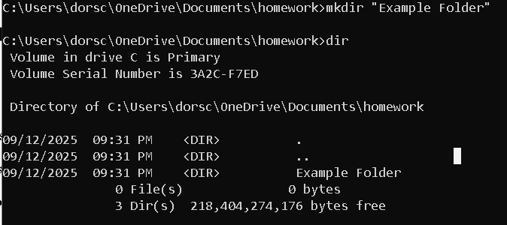
(Figure 2)
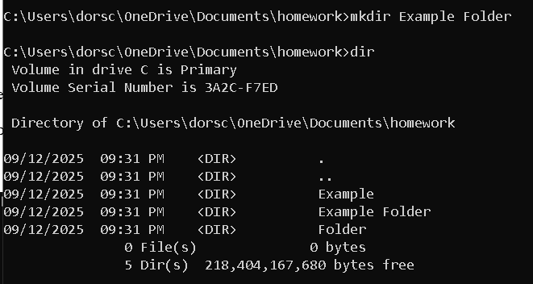
(Figure 3)
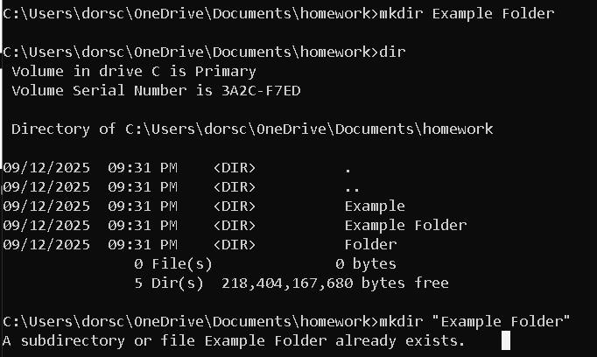

Conclusion
Understanding the CD, DIR, and MKDIR commands provides essential skills for navigating and managing the Windows CLI effectively. These commands allow users to move between directories, inspect folder contents, and create new directories as needed. While these tasks can also be performed through File Explorer, the CLI enables automation and precise control, which is invaluable for more advanced computing tasks. Learning these commands enhances efficiency and lays the groundwork for exploring more advanced command line operations and scripting.

References
Microsoft. (2023). MKDIR. Retrieved from https://learn.microsoft.com/en-us/windows-server/administration/windows-commands/mkdir
Microsoft. (2024). CD. Retrieved from https://learn.microsoft.com/en-us/windows-server/administration/windows-commands/cd
Microsoft. (2023). DIR. Retrieved from https://learn.microsoft.com/en-us/windows-server/administration/windows-commands/dir

